**Genii Analytics | Weighted AQA and SMART**

V1. April 2021

Contents

Purpose 2

Weights 2

# Purpose

This document is to provide detail on how the calculations and logic is set up for both these products.

# Set Weights

Weights are set on either:

1. Section - Level 1 questions or
2. Output Metrics – Level 2 questions

Examples for AQA

Sections: Resolution & Satisfaction, Business Efficiency, Regulatory Compliance and Voice of the Customer

Output Metrics: Issue Resolution, Ease of Understanding, Handled Interaction Efficiently, Repeat concern and Expression of Dissatisfaction.

Examples for SMART

Section: Opening, Compliance and Closing

Output Metrics (which will be actual questions): Did the agent advise the caller that the call is being recorded at the beginning of the call, Did the agent greet and introduce themselves and the company? and Did the agent use plain language?

Set Weights

To set weights on the Section level you will add a weight at this level.

The weight will be evenly distributed between the Output Metrics (second level questions) in that section.



To set the weights on the Output Metric Level you will need to add a tick to Auto Calculate Weight on the Section question.

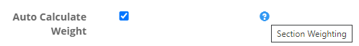

You will then add a weight to each individual Output Metric.

The sum of the individual Output Metric weights will become the Section Weight.

